1. SELECT nama_pelanggan, jenkel_pelanggan as 'jenis kelamin', tgl_transaksi

FROM pelanggan a

JOIN penjualan b

ON a.id_pelanggan = b.id_pelanggan

ORDER BY nama_pelanggan ASC;

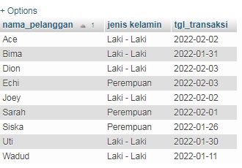

2. SELECT nama_pelanggan, jenkel_pelanggan as 'jenis kelamin', alamat, tgl_transaksi

FROM pelanggan a

LEFT JOIN penjualan b

ON a.id_pelanggan = b.id_pelanggan

ORDER BY nama_pelanggan ASC;

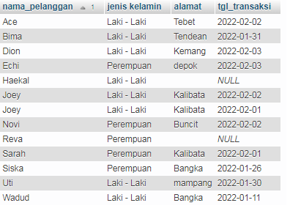

3. SELECT a.id_pelanggan, id_transaksi, nama_pelanggan

FROM penjualan a

RIGHT JOIN pelanggan b

on a.id_pelanggan = b.id_pelanggan

Order by id_pelanggan asc;

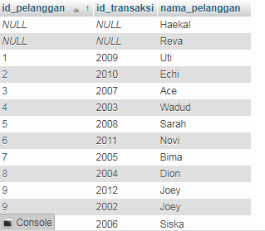

4. SELECT nama_pelanggan, nama_obat, jenis_obat as 'jenis Obat', alamat, total_bayar

FROM pelanggan a

JOIN penjualan b

ON a.id_pelanggan= b.id_pelanggan

JOIN penjualan_detail c

ON b.id_transaksi = c.id_transaksi

JOIN obat d

ON c.id_obat = d.id_obat

WHERE jenkel_pelanggan LIKE 'Perempuan'

AND alamat LIKE '%B%'

ORDER BY nama_pelanggan ASC;

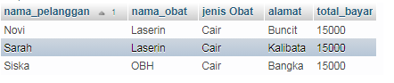

5. SELECT a.id_obat, id_transaksi, nama_obat, harga

FROM obat a

JOIN penjualan_detail b

ON a.id_obat = b.id_obat

WHERE harga < 12000

ORDER BY id_obat ASC;

